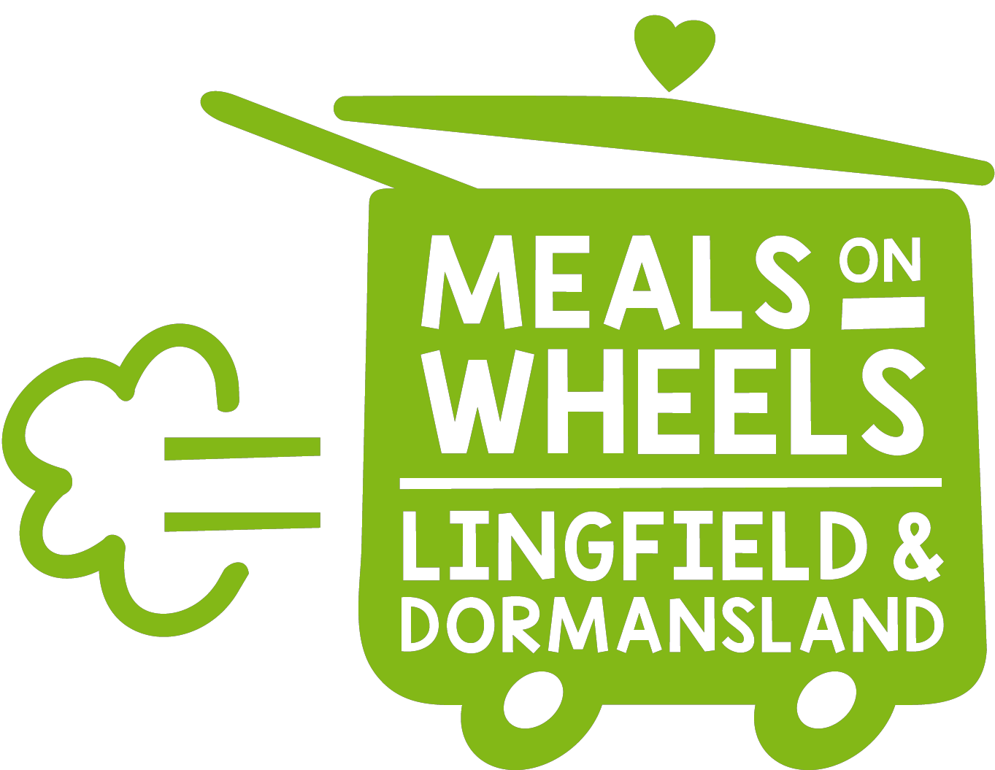 5
Food Standard Agency Rating
Registered Charity No 1165840

Are you aware of our Meals on Wheels Service in Lingfield, Dormansland Crowhurst and Felcourt ?

. Struggling to cook at home ?
. Can’t get out to the shops?
.Full time carer for a spouse or parent ?
. In need of post hospital recovery service?

We offer……
. Freshly cooked nutritious hot lunches Monday-Thursday .
. Fish and Chip option on Friday
. Delivered by local volunteers.
. A visit each day from a friendly face.
. Fresh local produce.
Call for a chat if you would like to discuss the service .Please call our Meals on Wheels phone 07504 481289
Or pop in and see us in the kitchen next to the Jennings Hall Monday -Thursday

